**FIRE DETECTION SYSTEM**

**T. E. Information Technology**

By

**Prithvi shetty 41**

**Abhishek sunkale 44**

**Smily tuscano 48**

Mentor:

**Dr. Prachi Raut**

Professor



Department of Information Technology

St. Francis Institute of Technology

(Engineering College)

University of Mumbai

2020-2021

**DECLARATION**

We declare that this written submission represents our ideas in our own words and where others' ideas or words have been included, we have adequately cited and referenced the original sources.

We also declare that we have adhered to all principles of academic honesty and integrity and have not misrepresented or fabricated or falsified any idea/data/fact/source in this submission.

We understand that any violation of the above will be cause for disciplinary action by the Institute and can also evoke penal action from the sources which have thus not been properly cited or from whom proper permission has not been taken when needed.

1. Prithvi shetty 41

(Name of student and Roll No.)

2. Abhishek Sunkale 44

(Name of student and Roll No.)

3. Smily Tuscano 48

(Name of student and Roll No.)

Date: 19 December 2020

**CERTIFICATE**

This Sensor Networks Lab Mini-project {Fire detection system} by {Prithvi Shetty,Abhishek sunkale and Smily Tuscano} is complete in all respects and was successfully demonstrated on {19/12/2020}.

Name : ---------------------------------------------

Signature :------------------------------------------

(Internal examiner)

Name : ---------------------------------------------

Signature :------------------------------------------

(External examiner)

Name : ---------------------------------------------

Signature :------------------------------------------

(Head of the Department)

Date: 19 December 2020

Place:

**CONTENTS**

|  |  |  |
| --- | --- | --- |
| **Chapter No.** | **Chapter Name** | **Page Number** |
| 1 | Introduction | 1 |
| 2 | Literature Review | 2-4 |
| 3 | Problem Statement | 5 |
| 4 | System Design and Requirements | 6-9 |
| 5 | Results | 10-11 |
| 6 | Conclusion and Future Scope | 12 |
|  | References | 13-14 |
| Annexure A | Arduino / Raspberry Pi code | 15-17 |

**Chapter 1**

**Introduction**

The Internet of Things (IoT) is a system of interrelated computing devices, mechanical and digital machines, objects, animals or people that are provided with unique identifiers and the ability to transfer data over a network without requiring human-to-human or human-to-computer interaction.The Internet of Things is actually a pretty simple concept, it means taking all the things in the world and connecting them to the internet.

In a metropolitan city like Mumbai with the presence of large of number of people homes poses a huge fire threat due to negligence and also with so many inflammable items –upholstery , decorative material , gas leaks,and electrical gadgets among others

India has lost 60,607 lives during the period 2015-18 of which 56% were accounted for home/residential fire.(ADSI).Thus residential fire becoming the largest source of fatalities.

Fire alarm and detection technology should help to detect fire at sufficiently early stage so that it can help to reduce the damage to human life and property

**Chapter 2**

**Literature Review**

In [1] the research paper,they have used arduino sensor,flame sensor that is lm 35 sensor and gsm module 800l.The system was user friendly and was built with simple hardware.This system could be easily implemented.

In [2] the research paper, they have used a dht11 sensor which was connected to the internet via wifi module to monitor temperature as well as humidity rate.The design and implementation was customizable and flexible.

In [3] research paper,they have used arduino uno,lm 35 and gsm module.The given device detected fire instantly when the temperature limit was reached,here they set the temperature limit as 44 degree celsius.

In [4] research paper,they have used 4 environment sensors , GSM module ,sg 90(servo motor) and Arduino pro mini to create SMS based fire alarm system.It was easily implemented and had maximum reliability since 4 environment sensors were used. This system could be used for home and industrial security system.

In [5] research paper,they have created GSM based fire alarm system uses GSM module , Arduino , LCD and LM35 as main temperature sensor.It was a low cost prototype and could be used for residential purposes to detect fire.

In [6] research paper, they have used Arduino Uno ,LM35 Temperature sensor , smoke detector and a low-cost Wifi chip:

ESP8266 which was used to create an sms based fire detection system.In this system it notifies via SMS system and is very reliable, efficient, and can be used for home security fire detection systems.

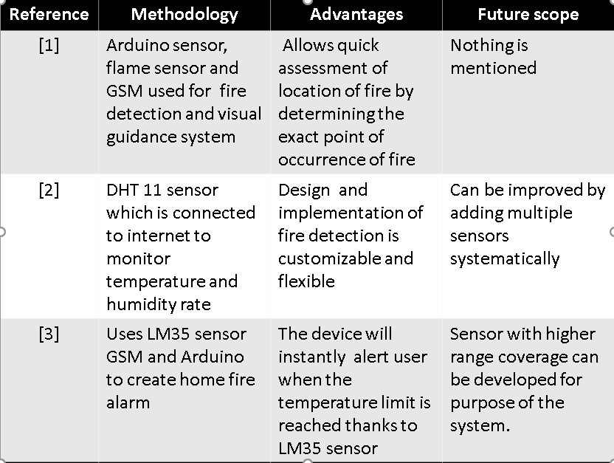

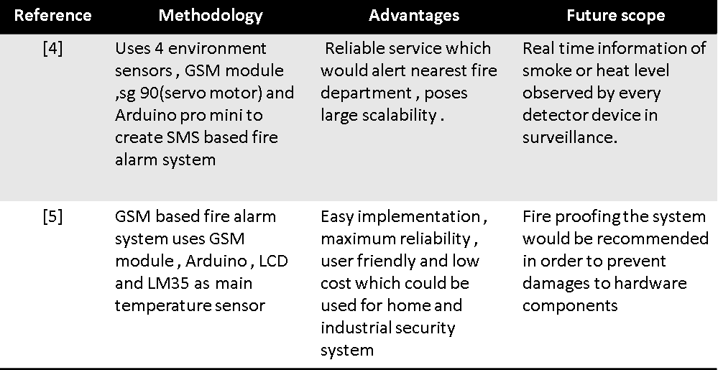

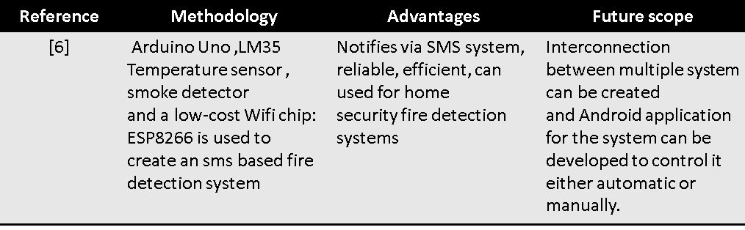

**Research gaps**

False alarm prevention should be installed.

Applications and monitoring systems should be developed for

android and other platforms for monitoring and controlling such systems

System can be optimized to make it more user friendly

**Chapter 3**

**Problem Statement**

To develop an IOT based fire detection system which can be used for houses and residential places to detect fire and alert the residents . Our system will use LM 35 temperature sensor and a GSM module in combination for reliability and data will be connected to IOT via SMS.

**Chapter 4**

**System Design and Requirements**

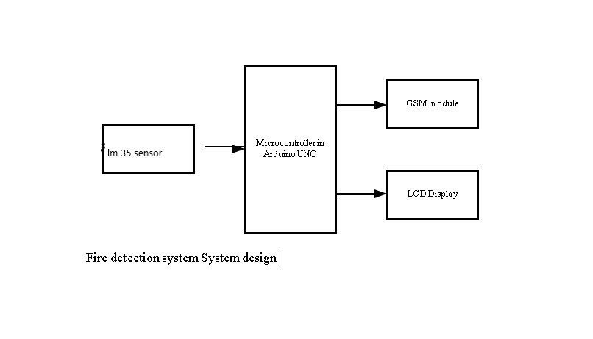

**Figure 1 [system design]**

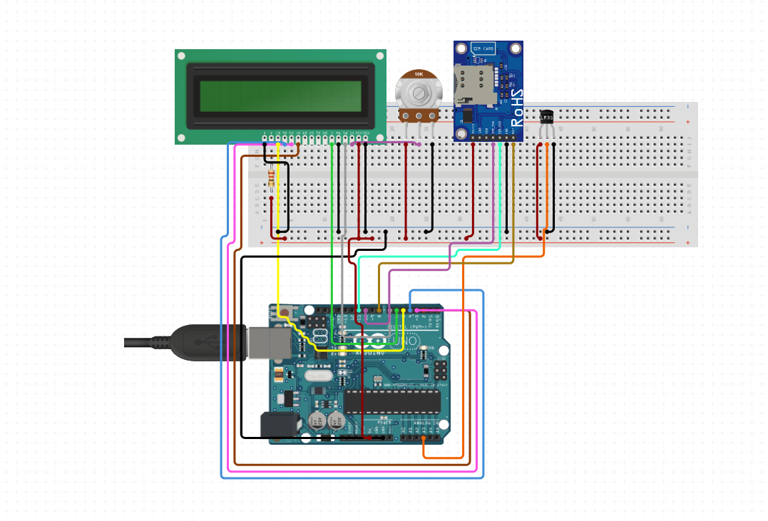

**Figure 2 [Circuit diagram]**

|  |  |  |  |  |  |  |  |  |  |
| --- | --- | --- | --- | --- | --- | --- | --- | --- | --- |
| **Hardware Components** | | | | | | | | | |
| **sr.no** | | **Component** | | | | **Numbers** | | **costs** | |
| **1** | | **Arduino Uno board** | | | | **1** | | **1*437=437** | |
| **2** | | **LM 35 sensor** | | | | **1** | | **123*1=123** | |
| **3** | | **LCD 16*2** | | | | **1** | | **1*255=255** | |
| **4** | | **GSM module** | | | | **1** | | **1*558=558** | |
| **5** | | **Breadboard** | | | | **1** | | **1*200=200** | |
| **6** | | **Jumper wires** | | | | **1 packet** | | **1*200=200** | |
| **7** | | **10 k potentiometer** | | | | **1** | | **130** | |
|  | | | | | | | | **Total=1903** | |
|  | | | | | | | | | |
| **Software Requirements** | | | | | | | | | |
| **sr.no** | | **Component** | | | | **costs** | |  |  |
| **1** | | **windows 10** | | | | **Rs 6000(not adding)** | |  |  |
| **2** | | **Circuito.io** | | | | **open source** | |  |  |
| **3** | | **Arduino ide** | | | | **open source** | |  |  |
|  |  |  |  |  |  |  |  | **Total = Rs 1903** |  |

**Chapter 5**

**Results**

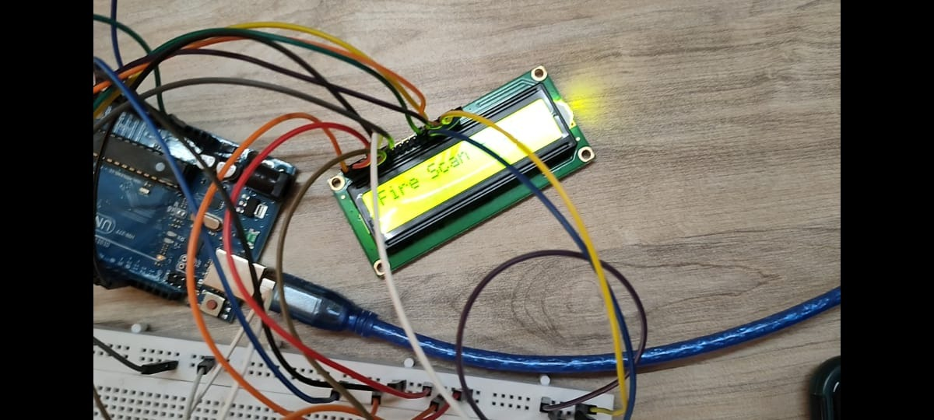

**Figure 3[lcd scan is on,displaying fire scan on the screen]**

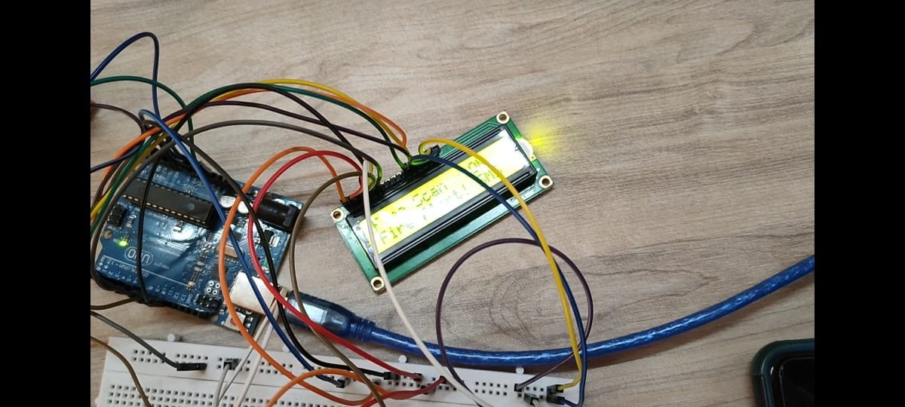

**Figure 4 [fire is detected by the lm 35 sensor as the temperature as risen above 45 degree celsius and fire alert is displayed on the lcd screen]**

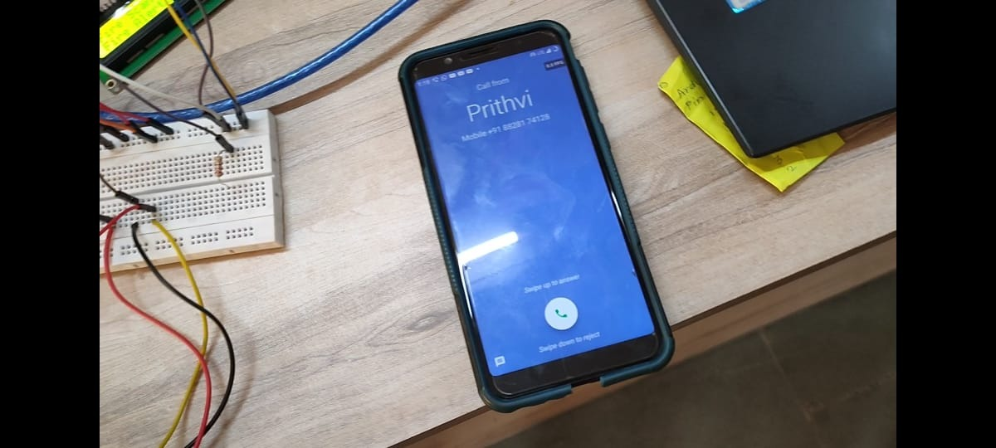

**Figure 5 [as fire is detected simultaneously a call and message is sent to user warning him/her that fire has taken place]**

**Chapter 6**

**Conclusions and Future Scope**

**Conclusion:**

We have developed a fire alarm system using the arduino and Lm 35 sensor. The developed prototype used reliable instruments that were suitable to develop a fire detector and it is an eco-friendly design

The total cost of this project was Rs.1903.The project was completed under the guidance of Dr . Prachi Raut.

**Future scope:**

Interconnection between multiple system.

Android application for the system to control it either automatic or manually.

Different sensors can be used such as gas sensor or smoke sensors.

**References**

[1]kumar, n. and kumari, p., 2018. Intelligent Fire Detection And Visual Guided Evacuation System Using Arduino And GSM. [online] Ijrter.com. Available at: <https://www.ijrter.com/papers/volume-4/issue-12/intelligent-fire-detection-and-visual-guided-evacuation-system-using-arduino-and-gsm.pdf> [Accessed 8 September 2020].

[2]Abdul Khaleq, Noor & Khalaf, Osamah & Addulsahib (2019). IOT fire detection system using sensor with Arduino. AUS. 74-78.available [online]:https://www.researchgate.net/publication/335790885_IOT_fire_detection_system_using_sensor_with_Arduino/link/5d7b7db84585155f1e3f2a3a/download [Accessed: 08- Sep- 2020].

[3]N. Mazhan, N. Enzai and N. Zin, "ShieldSquare Captcha", Iopscience.iop.org, 2020. [Online]. Available: https://iopscience.iop.org/article/10.1088/1742-6596/1019/1/012079/pdf. [Accessed: 08- Sep- 2020].

[4]Izang, A., Ajayi, S., Adeniye, F., &amp; Adepoju, A. (2018). An SMS Based Fire Alarm and Detection System. Retrieved September 08, 2020, from International Journal of Computer Trends and Technology (IJCTT) available at:https://www.ijcttjournal.org/2018/Volume58/number-1/IJCTT-V58P109.pdf

[5]Paul, D., Ghosh, A., &amp; Banerjee, S. J. (2016). GSM Based Fire Sensor Alarm Using Arduino. Retrieved September 08, 2020, from International Journal of Scientific &amp; Engineering Research available [online]:https://www.ijser.org/researchpaper/GSM-Based-Fire-Sensor-Alarm-Using-Arduino.pdf

[6]Shah, R., Satam, P., Sayyed3, M. A., &amp; Salvi, P. (2019). Wireless Smoke Detector and Fire Alarm System. Retrieved September 08, 2020, from International Research Journal of Engineering and Technology available at:https://www.irjet.net/archives/V6/i1/IRJET-V6I1258.pdf



**Annexure I**

**Arduino / Raspberry Pi Code**

**Code:**

#include <SoftwareSerial.h>

#include<LiquidCrystal.h>

LiquidCrystal lcd(12, 8, 5, 4, 3, 2);

SoftwareSerial mySerial(10, 11);

int sensor=A1;

float temp_read,Temp_alert_val,Temp_shut_val;

int sms_count=0,Fire_Set;

String number="+918850020119";

void setup()

{

pinMode(sensor,INPUT);

mySerial.begin(9600);

Serial.begin(9600);

lcd.begin(16,2);

delay(500);

}

void loop()

{

CheckFire();

CheckShutDown();

}

void CheckFire()

{

lcd.setCursor(0,0);

lcd.print("Fire Scan - ON");

Temp_alert_val=CheckTemp();

if(Temp_alert_val>45)

{

SetAlert(); // Function to send SMS Alerts

}

}

float CheckTemp()

{

temp_read=analogRead(sensor); // reads the sensor output (Vout of LM35)

temp_read=temp_read*5; // converts the sensor reading to temperature

temp_read=temp_read/10; // adds the decimal point

return temp_read; // returns temperature value in degree celsius

}

void SetAlert()

{

while(sms_count<3) //Number of SMS Alerts to be sent

{

SendTextMessage(); // Function to send AT Commands to GSM module

}

Fire_Set=1;

lcd.setCursor(0,1);

lcd.print("Fire Alert! SMS Sent!");

}

void CheckShutDown()

{

if(Fire_Set==1)

{

Temp_shut_val=CheckTemp();

if(Temp_shut_val<28)

{

lcd.setCursor(0,1);

lcd.print("Fire Shut! SAFE NOW");

SetAlert();

sms_count=0;

Fire_Set=0;

}}}

void SendTextMessage()

{

mySerial.println("AT+CMGF=1"); //To send SMS in Text Mode

delay(2000);

mySerial.println("AT+CMGS=\"+918850020119\"\r"); // change to the phone number you using

delay(2000);

mySerial.println("Fire in NEW ROOM!");//the content of the message

delay(200);

mySerial.println((char)26);//the stopping character

delay(5000);

mySerial.println("AT+CMGS=\"+918850020119\"\r"); // change to the phone number you using

delay(2000);

mySerial.println("Fire in NEW ROOM!");//the content of the message

delay(200);

mySerial.println((char)26);//the message stopping character

delay(5000);

sms_count++;

mySerial.print (F("ATD"));

mySerial.print (number);

mySerial.print (F(";\r\n"));

}